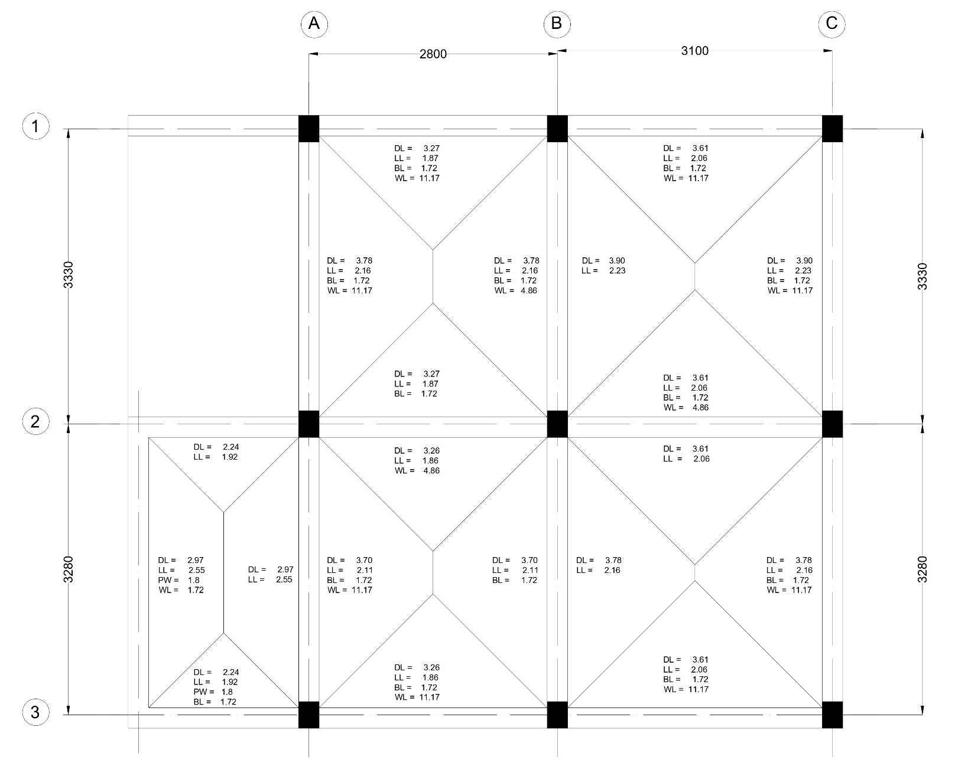
Figure 3.3: Roof slab loads.

